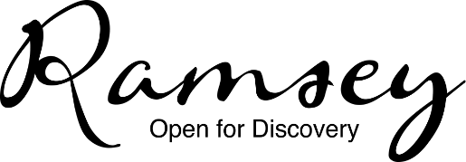
Cryptic Christmas Quiz – Can you work out all of these Christmas related things?
Return to Ramsey Library by Friday 17th December 2021 to win £25 to spend in your favourite Ramsey shop!
Name: | Telephone No:

Clue | Answer
1) Appointments
2) Half a board game
3) Pleasure in Ankara
4) 12 o’clock accumulation
5) Not out
6) Dad’s a barber
7) Mild green washing up liquid
8) ABCDEFGHIJKMNOPQRSTUVWXYZ
9) Before bumps and berries
10) Crimson burglar
11) Quiet Sir Lancelot
12) Foggy French digit
13) Not a southern stick
14) This snake is mixed up!
15) Pinched
16) Urban rhyming lyrics on a roll
17) STUN
18) Opposite a French stick
19) Hymn requires car maintenance
20) Amorous honey maker

