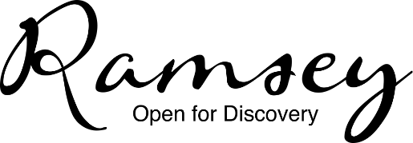
Cryptic Christmas Quiz – Can you work out all of these Christmas related things?
Return to Ramsey Library by Friday 17th December 2021 to win £25 to spend in your favourite Ramsey shop!
Name: | Telephone No:

Clue | Answer
Appointments | Dates
Half a board game | Gammon
Pleasure in Ankara | Turkish Delight
12 o’clock accumulation | Midnight Mass
Not out | Inn
Dad’s a barber | Parsnips
Mild green washing up liquid | Fairy
ABCDEFGHIJKMNOPQRSTUVWXYZ | Noel
Before bumps and berries | Goose
Crimson burglar | Red robin
Quiet Sir Lancelot | Silent Night
Foggy French digit | Mistletoe
Not a southern stick | North Pole
This snake is mixed up! | Present (serpent)
Pinched | Stollen
Urban rhyming lyrics on a roll | Wrapping paper
STUN | Mixed nuts
Opposite a French stick | Shortbread
Hymn requires car maintenance | Carol service
Amorous honey maker | Brandy

